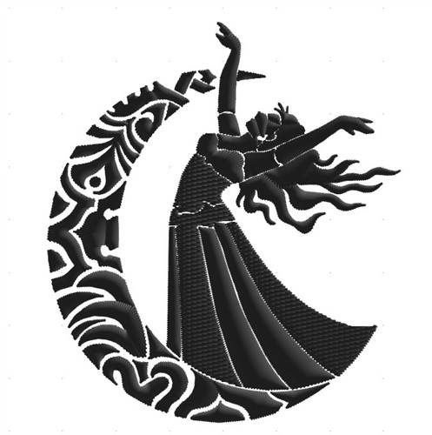

**Arabian Nights  
Party**

Friday 16th February  
2:00 – 3:00pm   
Here at [your facility]!  
 **Featuring:   
Kaylah the belly dancer**