

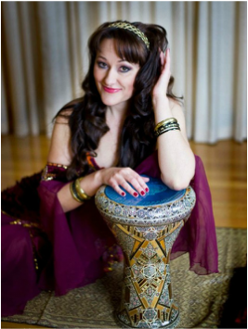

Friday 16th February  
2:00 – 3:00pm   
Here at [your facility] !  
  
**Featuring:   
Kaylah the belly dancer**

**Arabian Nights  
Party**

Made in Office 2007 for office2007.com